**Assignment Number 6 –** Using Data Analysis Pack

Register Number: 1740256

**Date:** 14/08/2017

1. **Aim** - Consider the marks obtained in an exam 24,27,36,48,52,52,53,53,59,60,85,90,95. using formula and data analysis tool pack. Find descriptive statistics for the following data using data analysis tool pack.

**Procedure** –

1. Using Data Analysis Tool Pack:
2. Enter the given data in an excel sheet.
3. Click on “Data” option in the Menu bar.
4. Click on “Data Analysis” option in the Analysis Box. A dialog box appears.
5. In the dialog box, click on “Descriptive Statistics” option and click on Ok. A dialog box appears.
6. Enter the range in the “Input Range” box.
7. Click on “New Worksheet Ply” and then select the option “Summary Statistics” and click on Ok. The Summary of the given data is observed.

**Calculations –**

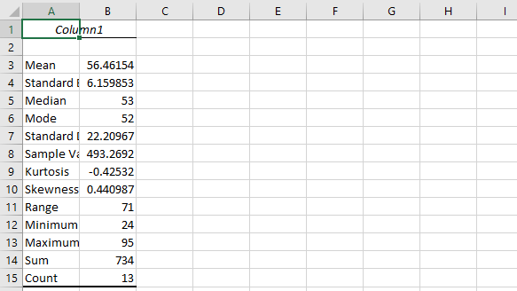

**Conclusion** –

The calculations show the marks obtained in an exam using data analysis tool pack.

|  |  |
| --- | --- |
| *Column1* | |
|  |  |
| Mean | 56.46154 |
| Standard Error | 6.159853 |
| Median | 53 |
| Mode | 52 |
| Standard Deviation | 22.20967 |
| Sample Variance | 493.2692 |
| Kurtosis | -0.42532 |
| Skewness | 0.440987 |
| Range | 71 |
| Minimum | 24 |
| Maximum | 95 |
| Sum | 734 |
| Count | 13 |

---------------------------------------------------------------------------------------------------------------------

**2)Aim** - The manager at a big restaurant has collected the information on the time take to process credit card payments by the counter at the counter staff. Find all the descriptive statistics using data analysis tool pack for this data.

1.57, 1.09, 1.13, 1.49, 0.98, 0.76, 1.40, 0.76, 1.38 ,1.29

1.59, 1.73, 2.31, 1.23, 1.89, 1.54, 1.97, 1.26, 0.27, 0.79

1.23, 1.56, 0.89, 1.78, 1.52, 1.07, 0.92, 1.38, 1.56, 1.98

* 1. , 4.89, 1.39, 1.76, 0.71 ,2.46, 0.89, 2.01, 3.21, 1.98

**Procedure** –

1. Using Data Analysis Tool Pack:

1. Enter the given data in an excel sheet.

1. Click on “Data” option in the Menu bar.
2. Click on “Data Analysis” option in the Analysis Box. A dialog box appears.
3. In the dialog box, click on “Descriptive Statistics” option and click on Ok. A dialog box appears.
4. Enter the range in the “Input Range” box.
5. Click on “New Worksheet Ply” and then select the option “Summary Statistics” and click on Ok. The Summary of the given data is observed.

**Calculations –**

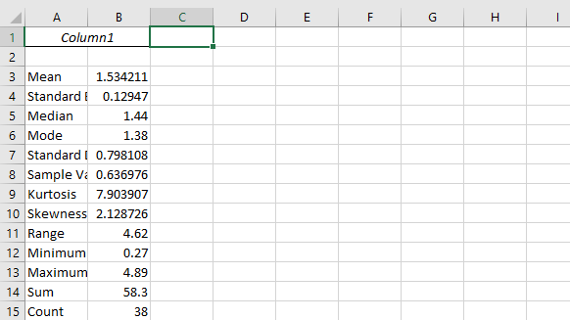

**Conclusion** –

The calculations show the descriptive statistics for the data mentioned above using data analysis tool pack.

|  |  |
| --- | --- |
| Mean | 1.534211 |
| Standard Error | 0.12947 |
| Median | 1.44 |
| Mode | 1.38 |
| Standard Deviation | 0.798108 |
| Sample Variance | 0.636976 |
| Kurtosis | 7.903907 |
| Skewness | 2.128726 |
| Range | 4.62 |
| Minimum | 0.27 |
| Maximum | 4.89 |
| Sum | 58.3 |
| Count | 38 |

---------------------------------------------------------------------------------------------------------------------

**3) Aim** - Find the Descriptive Statistics for the following data:

Vehicle mileage: 27, 29, 33, 21, 21, 12, 16, 25, 8, 17, 24, 34, 38, 15, 19, 19, 41

**Procedure** –

1. Using Data Analysis Tool Pack:

1. Enter the given data in an excel sheet.

1. Click on “Data” option in the Menu bar.
2. Click on “Data Analysis” option in the Analysis Box. A dialog box appears.
3. In the dialog box, click on “Descriptive Statistics” option and click on Ok. A dialog box appears.
4. Enter the range in the “Input Range” box.
5. Click on “New Worksheet Ply” and then select the option “Summary Statistics” and click on Ok. The Summary of the given data is observed.

**Calculations –**

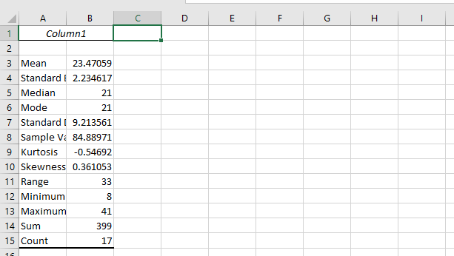

**Conclusion** –

The calculations show the Descriptive Statistics for the following data:

Vehicle mileage: 27, 29, 33, 21, 21, 12, 16, 25, 8, 17, 24, 34, 38, 15, 19, 19, 41

|  |  |
| --- | --- |
| Mean | 23.47059 |
| Standard Error | 2.234617 |
| Median | 21 |
| Mode | 21 |
| Standard Deviation | 9.213561 |
| Sample Variance | 84.88971 |
| Kurtosis | -0.54692 |
| Skewness | 0.361053 |
| Range | 33 |
| Minimum | 8 |
| Maximum | 41 |
| Sum | 399 |
| Count | 17 |

---------------------------------------------------------------------------------------------------------------------

**4) Aim** – The following data shows the marks scored by a student in his final exams. Find descriptive statistics for the data. Find descriptive statistics for the following data using data analysis tool pack.

98,87,78,90,85,82,93,91,88,99,73

**Procedure** -

1. Using Data Analysis Tool Pack:

1. Enter the given data in an excel sheet.

1. Click on “Data” option in the Menu bar.
2. Click on “Data Analysis” option in the Analysis Box. A dialog box appears.
3. In the dialog box, click on “Descriptive Statistics” option and click on Ok. A dialog box appears.
4. Enter the range in the “Input Range” box.
5. Click on “New Worksheet Ply” and then select the option “Summary Statistics” and click on Ok. The Summary of the given data is observed.

**Calculations –**

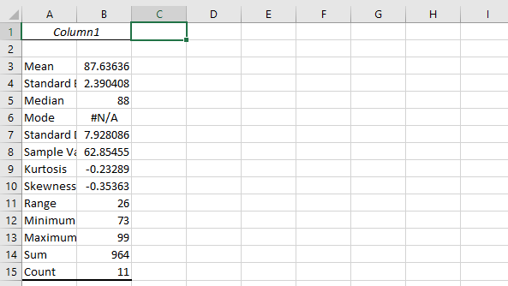

**Conclusion** –

The calculations show the Descriptive Statistics of the marks scored by a student in his final exams.

|  |  |
| --- | --- |
| Mean | 87.63636 |
| Standard Error | 2.390408 |
| Median | 88 |
| Mode | #N/A |
| Standard Deviation | 7.928086 |
| Sample Variance | 62.85455 |
| Kurtosis | -0.23289 |
| Skewness | -0.35363 |
| Range | 26 |
| Minimum | 73 |
| Maximum | 99 |
| Sum | 964 |
| Count | 11 |

---------------------------------------------------------------------------------------------------------------------

**5) Aim** – Thirty AA batteries were tested to determine how long they would last. The results, to the nearest minute, were recorded as follows:

423, 369, 387, 411, 393, 394, 371, 377, 389, 409, 392, 408, 431, 401, 363, 391, 405, 382, 400, 381, 399, 415, 428, 422, 396, 372, 410, 419, 386, 390

Find descriptive statistics for the following data using data analysis tool pack.

**Procedure** –

1. Using Data Analysis Tool Pack:

1. Enter the given data in an excel sheet.

1. Click on “Data” option in the Menu bar.
2. Click on “Data Analysis” option in the Analysis Box. A dialog box appears.
3. In the dialog box, click on “Descriptive Statistics” option and click on Ok. A dialog box appears.
4. Enter the range in the “Input Range” box.
5. Click on “New Worksheet Ply” and then select the option “Summary Statistics” and click on Ok. The Summary of the given data is observed.

**Calculations –**

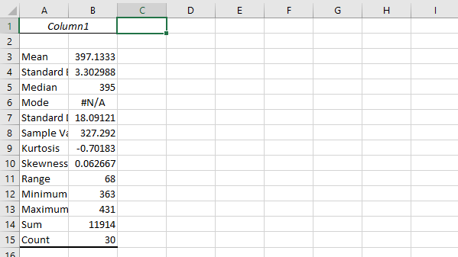

**Conclusion** –

The calculations show the Descriptive Statistics of the results, to the nearest minute of Thirty AA batteries which were tested to determine how long they would last.

|  |  |
| --- | --- |
| Mean | 397.1333 |
| Standard Error | 3.302988 |
| Median | 395 |
| Mode | #N/A |
| Standard Deviation | 18.09121 |
| Sample Variance | 327.292 |
| Kurtosis | -0.70183 |
| Skewness | 0.062667 |
| Range | 68 |
| Minimum | 363 |
| Maximum | 431 |
| Sum | 11914 |
| Count | 30 |

---------------------------------------------------------------------------------------------------------------------

**6) Aim** – The following data represents the percentage of people without health insurance for the 51 states and the District of Columbia in 2009. Find descriptive statistics for the following data using data analysis tool pack.

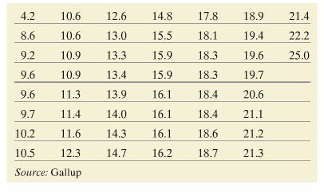

**Procedure** –

1. Using Data Analysis Tool Pack:

1. Enter the given data in an excel sheet.

1. Click on “Data” option in the Menu bar.
2. Click on “Data Analysis” option in the Analysis Box. A dialog box appears.
3. In the dialog box, click on “Descriptive Statistics” option and click on Ok. A dialog box appears.
4. Enter the range in the “Input Range” box.
5. Click on “New Worksheet Ply” and then select the option “Summary Statistics” and click on Ok. The Summary of the given data is observed.

**Calculations –**

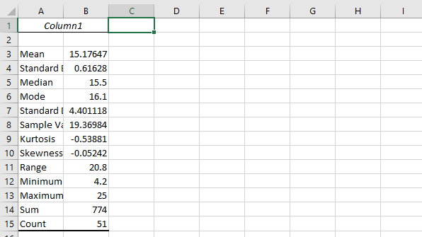

**Conclusion** –

The calculations show the Descriptive Statistics of the percentage of people without health insurance for the 51 states and the District of Columbia in 2009.

|  |  |
| --- | --- |
| Mean | 15.17647 |
| Standard Error | 0.61628 |
| Median | 15.5 |
| Mode | 16.1 |
| Standard Deviation | 4.401118 |
| Sample Variance | 19.36984 |
| Kurtosis | -0.53881 |
| Skewness | -0.05242 |
| Range | 20.8 |
| Minimum | 4.2 |
| Maximum | 25 |
| Sum | 774 |
| Count | 51 |

---------------------------------------------------------------------------------------------------------------------

**THE END**

---------------------------------------------------------------------------------------------------------------------